**BUG REPORTING**

**Bug Name**: Some translations are lost in pt liferay form exercise.

**Area Path**: Liferay Forms > Form Testing Exercise

**Build Number**: build_fake_3.SNAPSHOT

**Severity**: LOW (High/Medium/Low)

**Reported By**: Alfredo Soto

**Reported On**: 13/12/2021

**Reason**: Defect

**Test Case Related:** #2

**Status**: Open

**Environment**: Windows 10 + Chrome Version 96.0.4664.93 (Build official) (64 bits)

**Description**: Liferay Form Testing exercise are shown English text when pt language is selected.

**Steps to Reproduce**:

1) Go to https://forms.liferay.com/web/forms/shared/-/form/122548

2) Change language to pt

3) Some texts are not translated to pt and are shown in English:

* Let's party rock.
* Indicates Required Fields.
* Data picker months.

See attached screenshot to see it:

**Expected Result**: All messages should be displayed in language selected. In this case, in pt.

**Screenshots:**

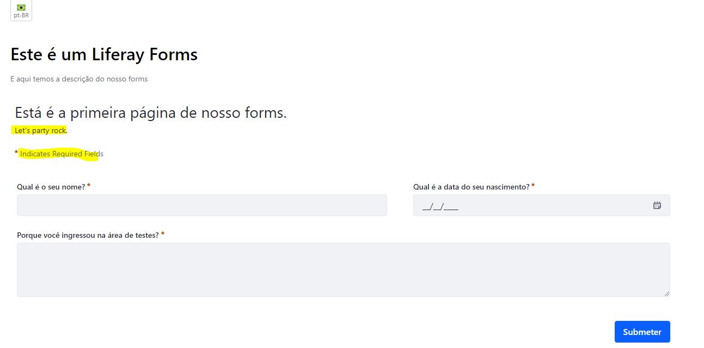

**Bug Name**: Some translations are lost in pt succeed page Liferay form exercise.

**Area Path**: Liferay Forms > Form Testing Exercise

**Build Number**: build_fake_3.SNAPSHOT

**Severity**: LOW (High/Medium/Low)

**Reported By**: Alfredo Soto

**Reported On**: 13/12/2021

**Reason**: Defect

**Test Case Related:** #3

**Status**: Open

**Environment**: Windows 10 + Chrome Version 96.0.4664.93 (Build official) (64 bits)

**Description**: Liferay Form Testing exercise are shown English text when pt language is selected on succeed page.

**Steps to Reproduce**:

1) Go to https://forms.liferay.com/web/forms/shared/-/form/122548

2) Change language to pt

3) Fill a form using valid data and click submit button:

4) Page shown after form is succeed is only displaying English messages.

See attached screenshot to see it:

**Expected Result**: All messages should be displayed on language selected. In this case, in pt.

**Screenshots:**

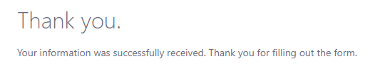

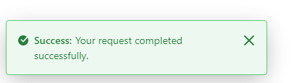

**Bug Name**: Inconsistent behaviour of dob field using data picker or typing a date.

**Area Path**: Liferay Forms > Form Testing Exercise

**Build Number**: build_fake_3.SNAPSHOT

**Severity**: LOW (High/Medium/Low)

**Reported By**: Alfredo Soto

**Reported On**: 13/12/2021

**Reason**: Defect

**Test Case Related:** NONE (Exploratory testing)

**Status**: Open

**Environment**: Windows 10 + Chrome Version 96.0.4664.93 (Build official) (64 bits)

**Description**: Date of birth field is shown different behaviour depending if we selected from data picker or I type it.

**Steps to Reproduce**:

1) Go to https://forms.liferay.com/web/forms/shared/-/form/122548

2) Fill a Name and a testing reason with valid data.

3) Choose a date using data picker

4) Delete two numbers of year selected using keyboard and click Submit.

5) Repeat operation until step 3 and type the dob: 12/12 and click submit

6) Repeat steps and click submit

See video attached

**Expected Result**: Same behaviour in each case. Sometimes are displayed a different message error and sometimes the form is sent. See video until the end.

**Video:**

inconsistent_behaviour_dob video next to this file.

**Bug Name**: Two different errors shown at dob field

**Area Path**: Liferay Forms > Form Testing Exercise

**Build Number**: build_fake_3.SNAPSHOT

**Severity**: LOW (High/Medium/Low)

**Reported By**: Alfredo Soto

**Reported On**: 13/12/2021

**Reason**: Defect

**Test Case Related:** NONE (Exploratory testing)

**Status**: Open

**Environment**: Windows 10 + Chrome Version 96.0.4664.93 (Build official) (64 bits)

**Description**: Date of birth field is shown different behaviour depending if we selected from data picker or I type it.

**Steps to Reproduce**:

1) Go to https://forms.liferay.com/web/forms/shared/-/form/122548

2) Fill a Name and a testing reason with valid data.

3) Choose a date using data picker

4) Delete two numbers of year selected using keyboard and click Submit.

5) Repeat operation until step 3 and type the dob: 12/12/20 and click submit

6) Repeat steps and click submit

See video attached

**Expected Result**: Same behaviour in each case. Sometimes are displayed a different message error and sometimes the form is sent.

**Video:**

dob_both_errors_displayed video next to this file

**Screenshots:**

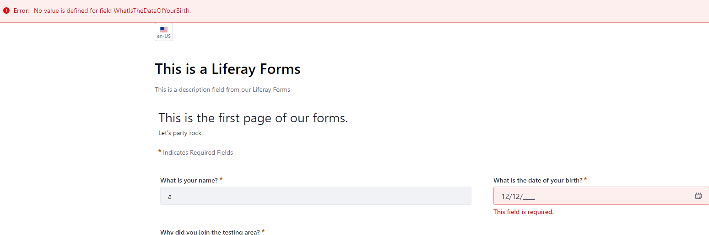

**Other considerations**

* Related with dob field, when this error is shown:



I would say that WhatIsTheDateOfYourBirth es the key of the message and it is not displaying the value itself.

* I don’t know if we can considerer a bug or not (maybe it’s a feature ;) but I would say YES ) but tab functionality is not working properly because it’s selecting label field instead to focus on the text box:

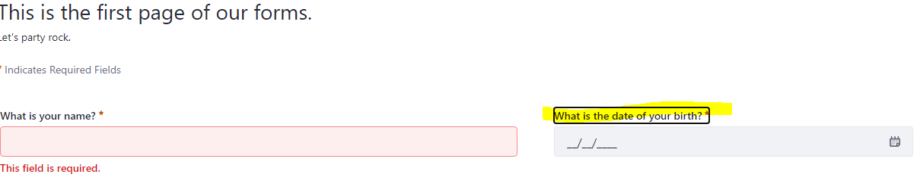

To sum up, I would say that apart from how to reproduce the error, add a video or a screenshot is important, as well provide logs if we can.